* 1. Select all universities. Show name and accreditation

db.universities.find( { }, { name : 1, accreditation : 1, _id: 0} );

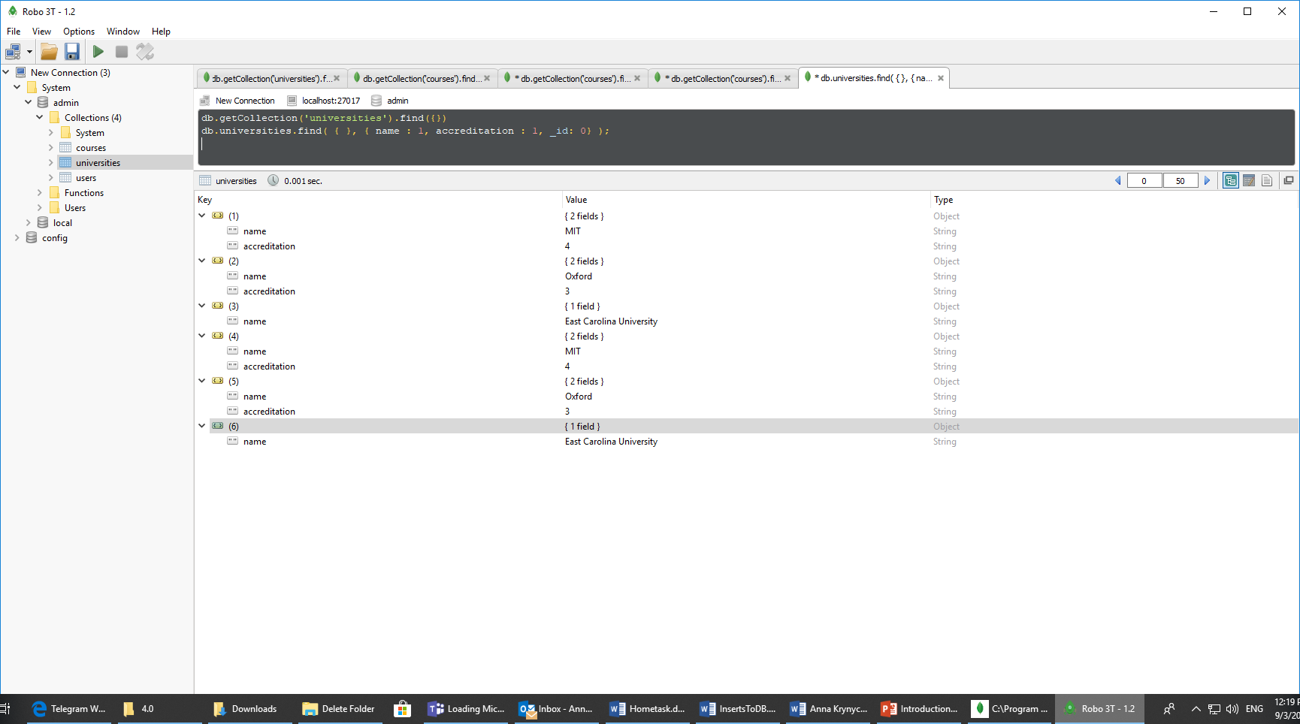

* 1. Select university without coordinates. Show only Address information.

db.universities.find({ "address.coordinates" : { "$exists" : false }} ,{ address :1 , _id : 0 })

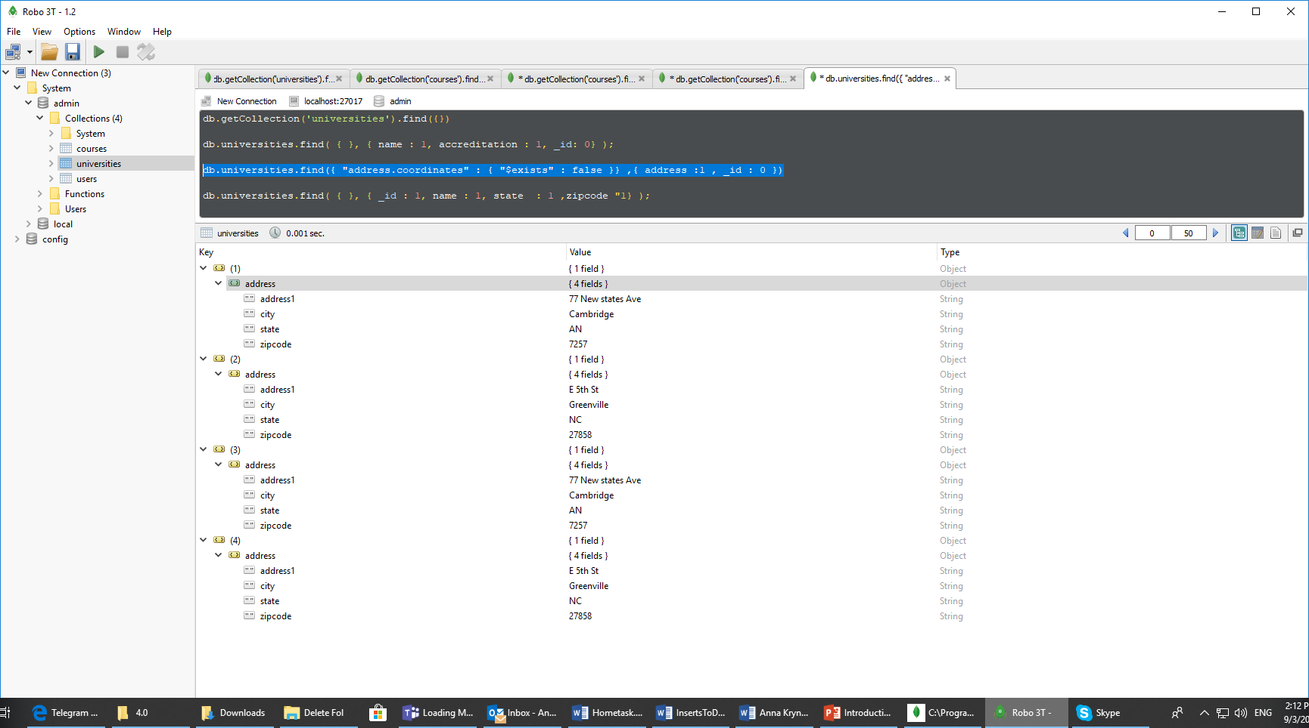

* 1. Select university with State = “MA” and zipcode **not** equal to “27897”. Show id, name, state, zipcode

db.universities.find( { "address.state" : "MA", "address.zipcode": { $ne: "27897"} }, { _id : 1 , name : 1 , "address.state" : 1 , "address.zipcode" : 1 } );

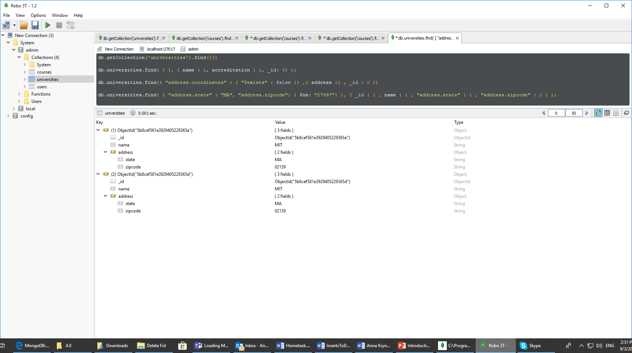

* 1. Select users with Date of Birth more than (>) 1980 year and less than current date. Show only Date of Birth

db.users.find({DateOfBirth : {$gte: ISODate("1980-01-01T00:00:00.000Z"), $lte: new Date()}},{DateOfBirth : 1, _id : 0 } )

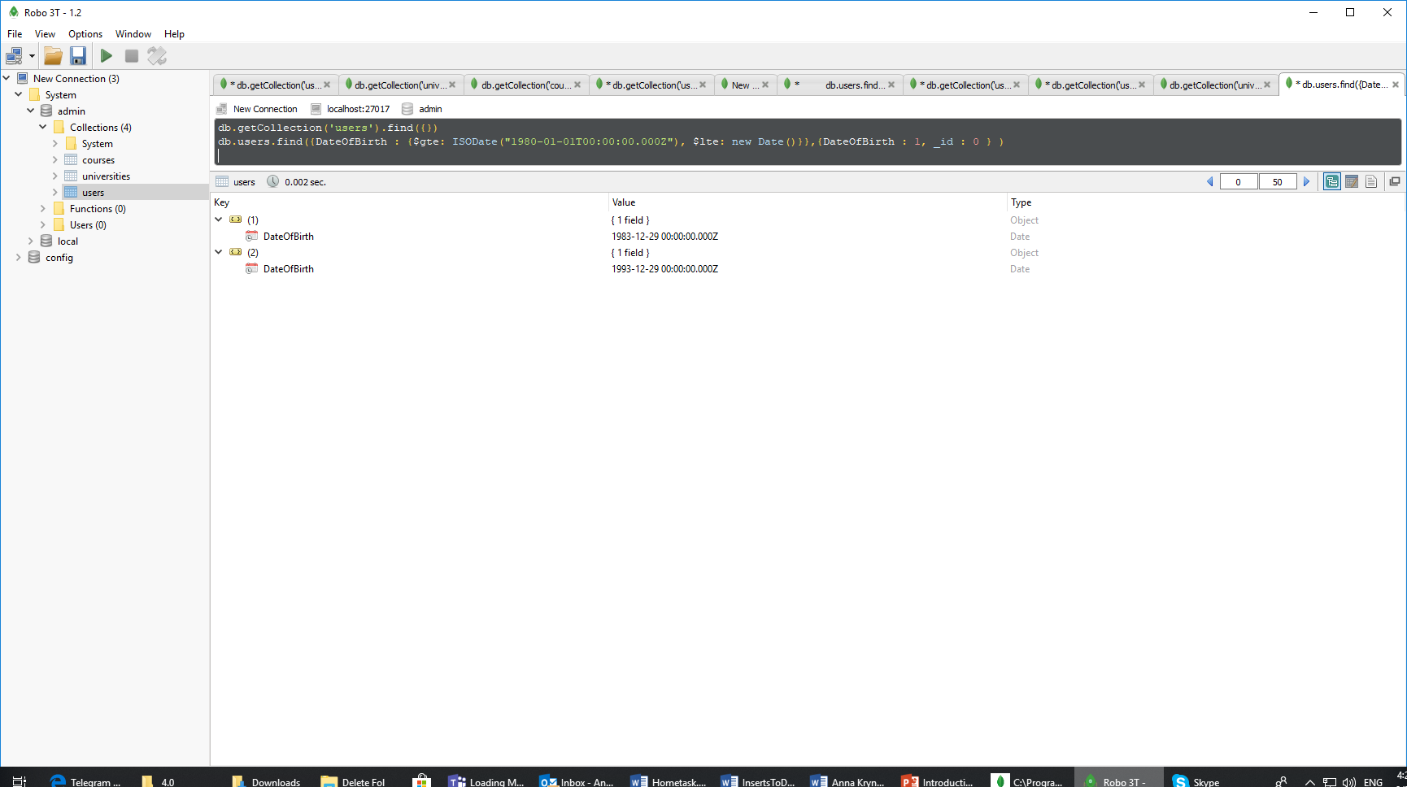

* 1. Change course name and delete all other information (university_id, users) for course, which contains only students.

db.courses.update({'users.role' : {$nin : ["instructor"]}}, {$set : {'name' : 'Newcourse'}}, {multi : true})

db.courses.update({'users.role' : {$nin : ["instructor"]}}, {$unset : {'university_id' : 1, 'users' : 1}}, {multi : true})

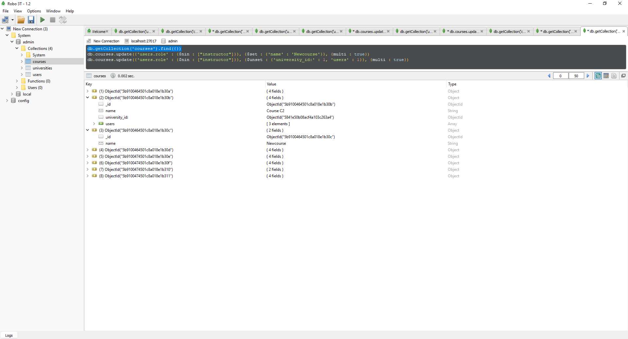

* 1. Select courses with max number of users. Show course name, user roles, amount of users.

db.courses.find({},{_id:0, name:1, "users.role":1}).sort({users: -1}).limit(1)

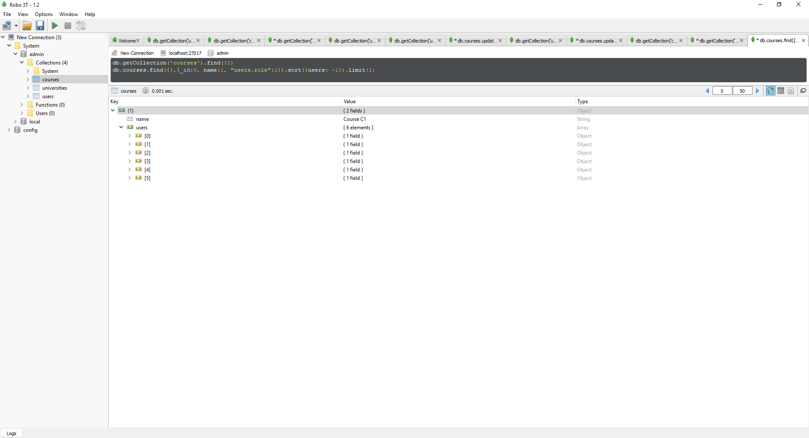

* 1. *Select user with the longest MiddleName. Show _id, MiddleName, length.

db.users.find({},{_id:1,MiddleName :1, lenght:1}).sort({MiddleName: -1}).limit(1)

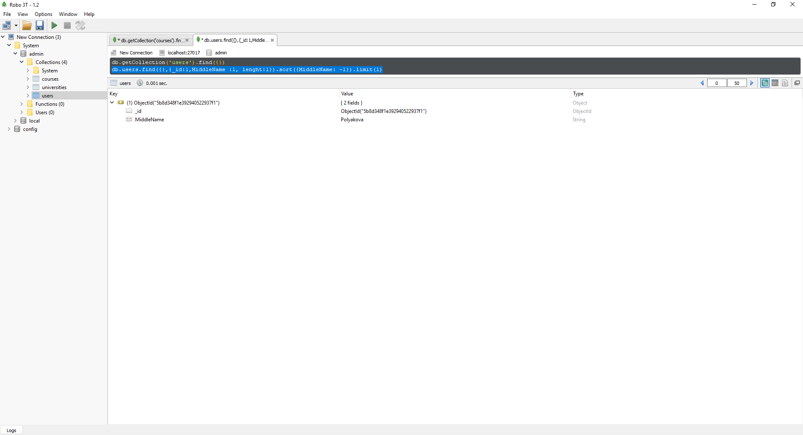

* 1. Update ***only*** the course name, which contains every user role.

db.courses.updateMany({$and : [{"users.role" : "instructor "}, {"users.role":"admin"},{"users.role":"student" }]},{$set :{"name": "updated"}},{multi: true })

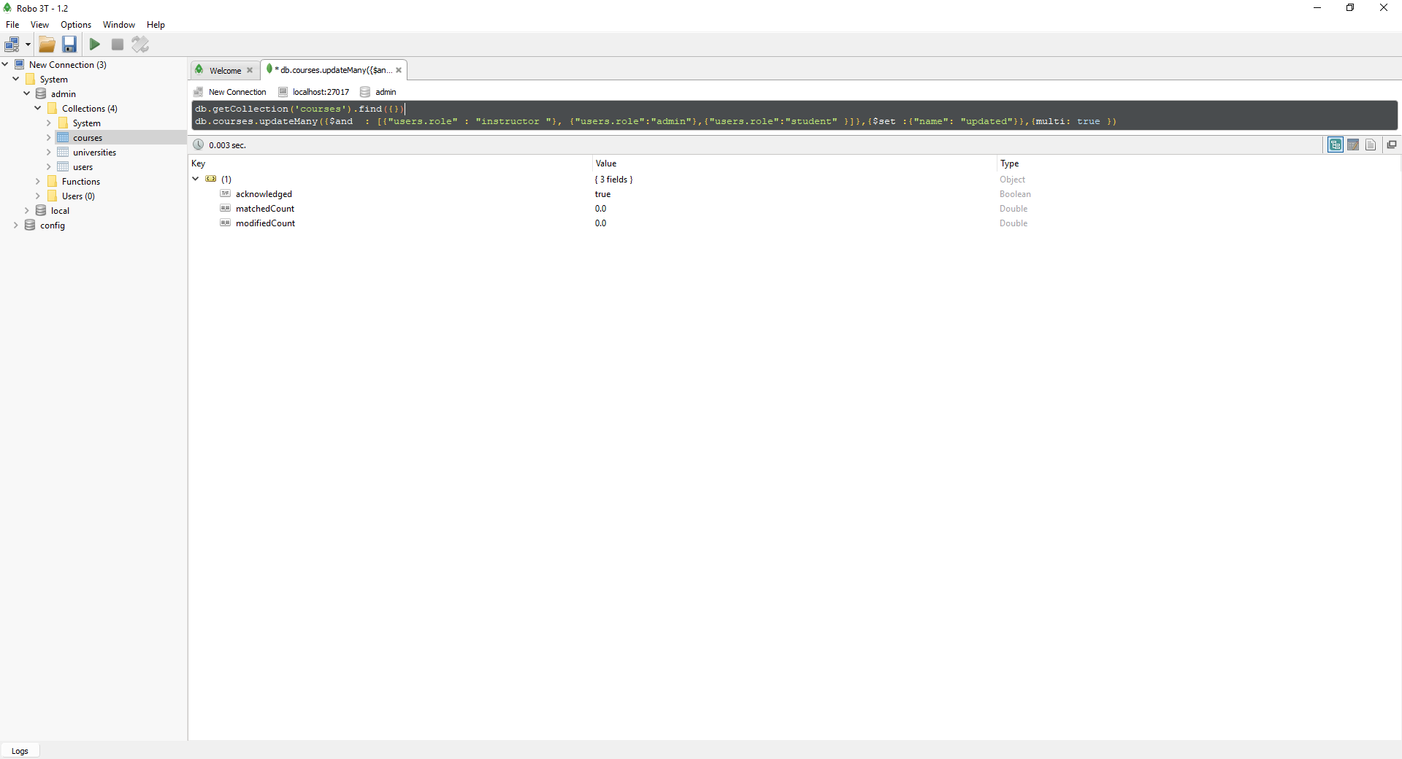

* 1. Replace User document with Name = “Pavel” (insert your values and pay attention for the new structure. Use .find() before replacement and compare values after)

db.getCollection('users').replaceOne({'FirstName':'Pavel'},{'FirstNme':'Vova'})

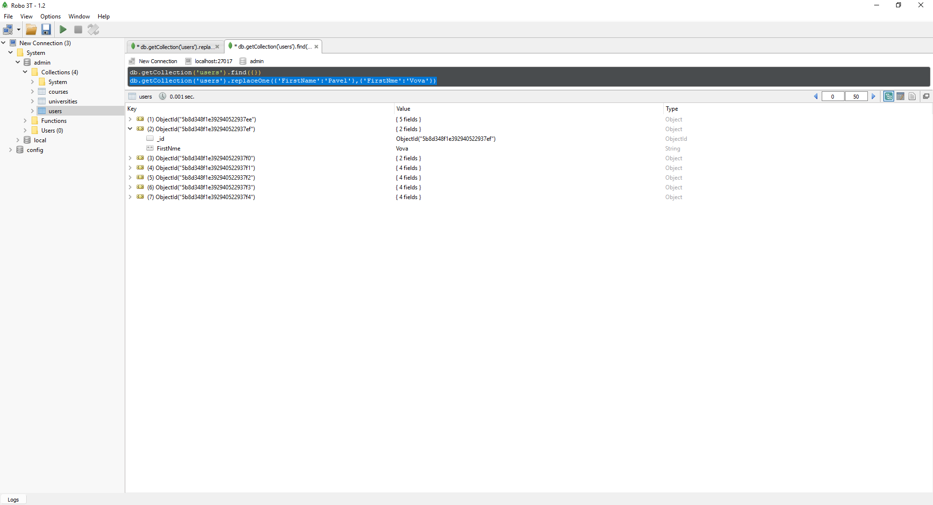

* 1. Delete user which has only LastName by 2 ways (use delete()and remove() commands)(i.e. MiddleName, Date of Birth, First Name are null).

db.users.deleteOne({FirstName : {$exists : false }},{DateOfBirth : {$exists : false }},{MiddleName : {$exists : false}})

